Regulations:
A18

H.T No

Sreenidhi Institute of Science and Technology
(An Autonomous Institution)
Code No: 7EC01 Date: 18-June-2019 (FN)

B.Tech I-Year II-Semester External Examination, June-2019 (Regular)
DATA STRUCTURES (CSE and IT)

Time: 3 Hours Max.Marks:70

Note: a) No additional answer sheets will be provided.
b) All sub-parts of a question must be answered at one place only, otherwise it will not be valued.
c) Missing data can be assumed suitably.

Part - A Max.Marks:20

Answer all QUESTIONS.

1. | Write equivalent postfix expression to the following.  (A+B)-(C+D*E)/F*G | [2M]
2. | Differentiate a circular singly linked list from a singly linked list. | [2M]
3. | Find the adjacency matrix for the given directed graph.  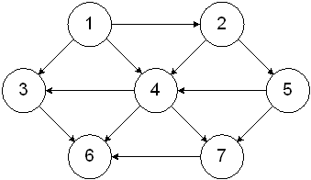 | [2M]
4. | Write the algorithm of linear search. | [2M]
5. | What is the significance of static members of a class? | [2M]
6. | Illustrate the use of “this” Pointer in c++. | [2M]
7. | What is Queue and write briefly about various Queue operations? | [2M]
8. | Write In order, Pre order and Post order traversals for a given binary tree.  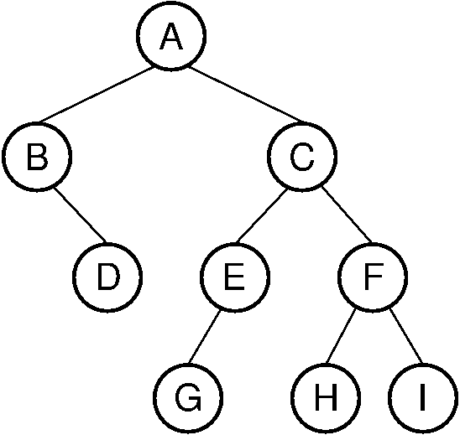 | [2M]
9. | Define Template. | [2M]
10. | Write the algorithm of bubble sort. | [2M]
Part – B Max.Marks:50
ANSWER ANY FIVE QUESTIONS. EACH QUESTION CARRIES 10 MARKS.

11. | a) | Explain the Array implementation of stacks. | [7M]
 | b) | Write the applications of queue. | [3M]
12. |  | Explain about Double Linked List in detail with example. Write functions to  i) Insert elements  ii) Delete elements  iii) Display elements | [10M]
13. | a) | Construct an AVL tree using the following data entered in sequence  7,14,2,5,10,23,90,30,15,25,66,70,4 | [7M]
 | b) | List the various representations of graphs. | [3M]
14. | a) | Explain the insert operation on MAX Heap. | [5M]
 | b) | Sort the given list of numbers using Insertion sort. Show the arrangement of 64,57,32,45,9,12,18,7 elements with each iteration. | [5M]
15. | a) | What are constructors and destructors? What are their characteristics? | [5M]
 | b) | Explain different types of constructors with examples. | [5M]
16. | a) | Define operator overloading. Write a program to overload binary '+' operator. | [5M]
 | b) | Explain different types of inheritance with suitable examples. | [5M]
17. | a) | Write an algorithm to convert infix expression into postfix. | [4M]
 | b) | Write an algorithm to count the number of nodes in a circular singly linked list. | [3M]
 | c) | What is a Binary Tree? Give an example for Binary Tree representation. | [3M]
18. | a) | Write a 'C' program of binary search using recursion to search for a given element. | [4M]
 | b) | Explain how an Object oriented Program approach differs from structured programming approach? | [3M]
 | c) | Explain friend function. | [3M]

-- 00 -- 00 –

